Function
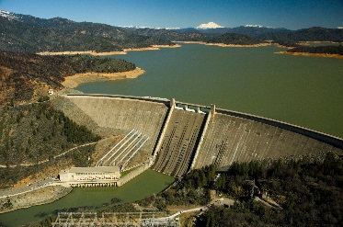
Storage dam
Fig.1
Storage dams are the most common type of dam and are used to store water for many purposes. Often, they are used to hold water from winter/spring for summer, when water is sparse, for either irrigation or a general water supply. Also, they can be used to improve the habitats of nearby wildlife. They are commonly used to impound
water, ready to be used in a hydroelectric scheme, or even just to prevent flooding.
Diversion dam
Fig.2
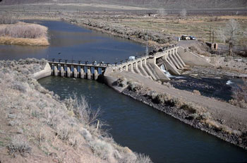
A diversion dam is normally quite short and is used to direct water from a river into a conduit. These dams are used to direct water into canals, irrigation systems or to other storage reservoirs which are distance away from the river.

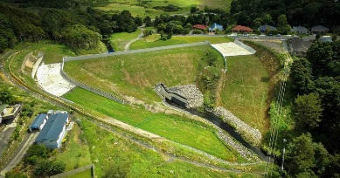
Detention dam
Fig. 3
Detention dams are used as a flood control. They constrict the flow of the river by storing the flood water. Then it releases the water in a controlled fashion, preventing any damage coming to the downstream area.

Coffer dam
Fig. 4
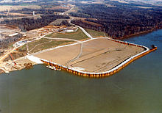
Coffer dams are used for construction, they are temporary dams which are implemented to allow you to build on the bed of the river or lake.

Construction
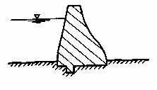
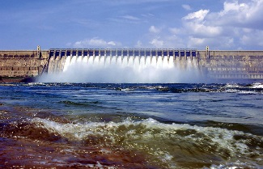
Gravity dam
Fig. 5
A gravity dam is a massive object usually made of concrete or stone masonry. They are designed such that they can hold back large bodies of water. This is because the concrete object is large enough to overcome the horizontal force of the water.

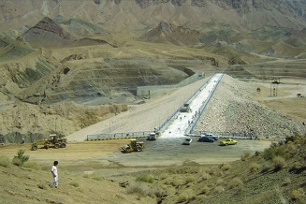
Earth dam
Fig. 6
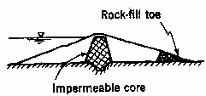
Earth dams are built by having compact layers of earth built up, with an impermiable core. Also they usually have a concrete spillway to control any overflow, should it ever occur. These dams dont need to be built on solid foundations.
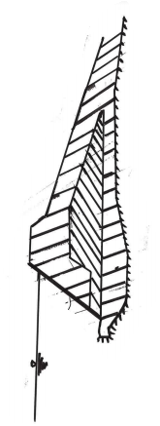
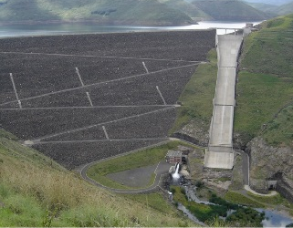
Rockfill dams
Fig.7
Impermeable Membrane
These dams are built of large rocks and boulders. On the upstream side, there is an impermiable membrane, usually a concrete variant, to minimise seepage through the dam.

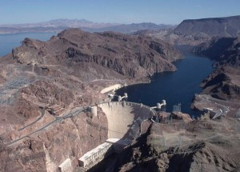
Arch dam
Fig. 8
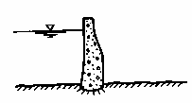
Arch dams are curved downstream, so that the pressure of the water is transferred to the abutments at the ends of the dam. These dams are best suited for narrows gorges, which are sound enough to resist the force exerted on the flanks by the arch.

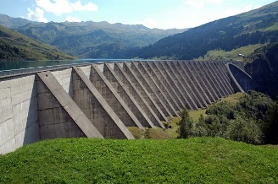
Buttress dam
Fig. 9
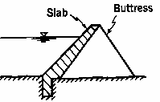
A buttress dam consist af a deck ( a reinforced conctrete slab), supported by n umerous buttresses. The deck spans the width of the valley, and is the component which holds the water. The buttresses transmit the force of the water pressure onto the foudation from the deck.

Materials
Gravity Dam | Concrete, rubble masonry
Earth dam | Earth/soil, clay and fine sand
Rockfill dam | Earth, rock fragment, concrete
Arch dam | concrete
Buttress dam | Concrete (also timber and steel)

Appendix.
Fig.1 – shasta dam, sacremento river, California
Fig. 2 – Derby dam, truckee river, Nevada
Fig. 3 - Hopua te Nihotetea Detention Dam, Whāngārei, NZ
Fig. 4- Ohio river, Illinois
Fig. 5 - Nagarjuna Sagar Dam, India
Fig. 6 - Nahrain Reservoir Dam, Iran
Fig. 7 - Mohale dam, Lesoto Africa
Fig. 8 - Hoover Dam, USA
Fig. 9 – Roselend Dam, france

