World’s largest dam.
The world’s largest dam (by volume of the structure) is the Tarbela dam in Pakistan, at 153million cubic metres. The dam impounds the Indus river and is 148m high. It took eight years to build, finishing in 1976. The dam was built with the purpose of holding water from the Indus for irrigation, flood control and generating hydroelectric power.
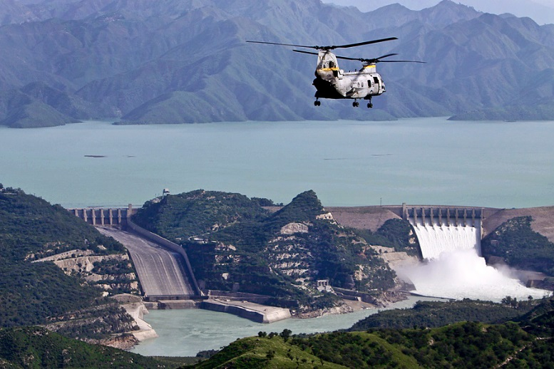
The construction of the bridge was undertaken in three stages. The first stage took 2.5 years. Within this time the indus was allowed to flow as usual as all the construction, at this stage, was on the right bank. A 475x212 metre diversion chanel was being excavated, at the same time as there was a 32m high buttress dam being constructed.
In stage two, which took 3 years, the main dam was constructed across the valley of the river as the water was being diverted through the channel, which was dug in stage 1. As this stage finished, the tunnels had been built for diversion in stage two.
In the third stage work was undertaken to refill the diversion chanel and then construct the dam in that area. The main dam was finished at the higher levels, within this stage too.

The world’s tallest dam.
The world’s tallest dam is the Jinping-I dam in china, at 305m. the bridge took eight years to build and finished in 2013. The dam is a gravity arch dam and was built for the purpose of supplying energy to the rapid expansion of industrialisation, improve flood protection and prevent erosion.
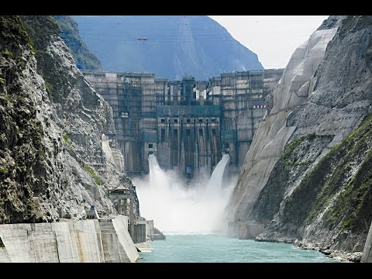

The world’s most expensive dam.
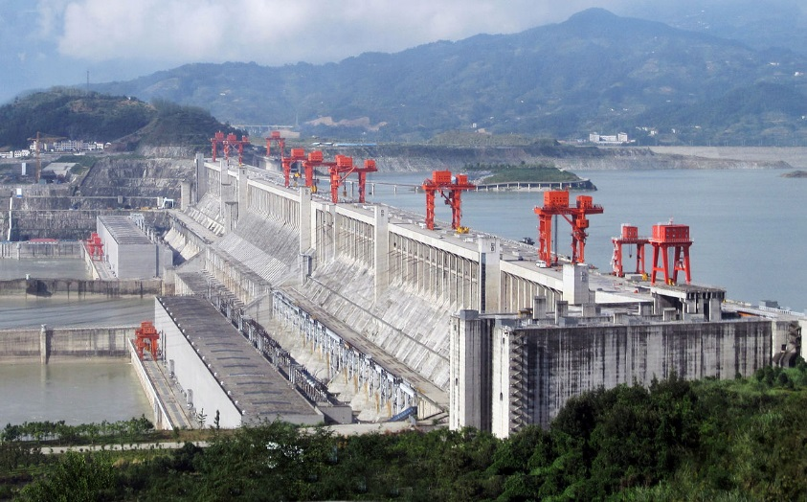
The three gorges dam is estimated to have cost $28 billion dollars. Which would make it the most expensive dam in he world. The dam is on the Yangtze river in china and can generate 84.7 billion KW of power each year, which is enough to supply china with 10% of its electricity. The dam took 9 years to build, opening in 2003.

